Flipped teaching as a method for boosting engagement and performance

Dr Sam Marsh* and Dr Nick Gurski

School of Mathematics and Statistics, University of Sheffield

Abstract: In a large-scale trial at the University of Sheffield (n=236), we implemented a flipped approach to teaching mathematics to first-year engineers. Lectures were discontinued and replaced with an integrated format of specially filmed short videos, online quizzes and twice as much small-group learning. We found strong evidence that engagement and exam performance were boosted by the new method by comparing with students on an identical syllabus taking the same exam but taught traditionally.

Keywords: flipped teaching, mathematics, video, blended learning, engagement, large groups.

*Correspondence to: Sam Marsh, School of Mathematics and Statistics, University of Sheffield, United Kingdom. E-mail: s.j.marsh@sheffield.ac.uk

1. Introduction

1.1 Background
The School of Mathematics and Statistics provides mathematics teaching for undergraduate students in the Faculty of Engineering at the University of Sheffield. Predominantly, these modules have been taught in a traditional format of two large-group lectures (200 students or more) and one smaller-group problem class (approximately 40-50 students) per week. Attendance records are kept for problem classes but not lectures. We find that attendance usually starts high, but drops off as time progresses (see Figure 1).

A working group was established to look into the effectiveness of these modules, with a particular focus on whether a flipped approach, based around videos, online tests and small-group classes, could provide a more engaging course for students.

The working group established a key proposal: that large-group lectures would be discontinued, and their content split into theory (to be included in the videos) and examples (to be done in classes). Further, the amount of contact time allocated to small-group learning would be doubled. This approach was to be piloted on a first-year module of 236 students, with two other modules totalling 298 students which cover an identical syllabus but taught traditionally used as a comparison.

1.2 Literature
Flipped teaching currently has a high profile in pedagogical discussion, with case-studies such as Marcy and Brint (2012) showing promising results. Web-based learning and assessment for mathematics in particular is receiving attention at all levels of education. This is driven by flexible assessment (Lin and Hsieh, 2001) as well as the ability to vary learning activities and examples (Mavrikis and Maciocia, 2003).

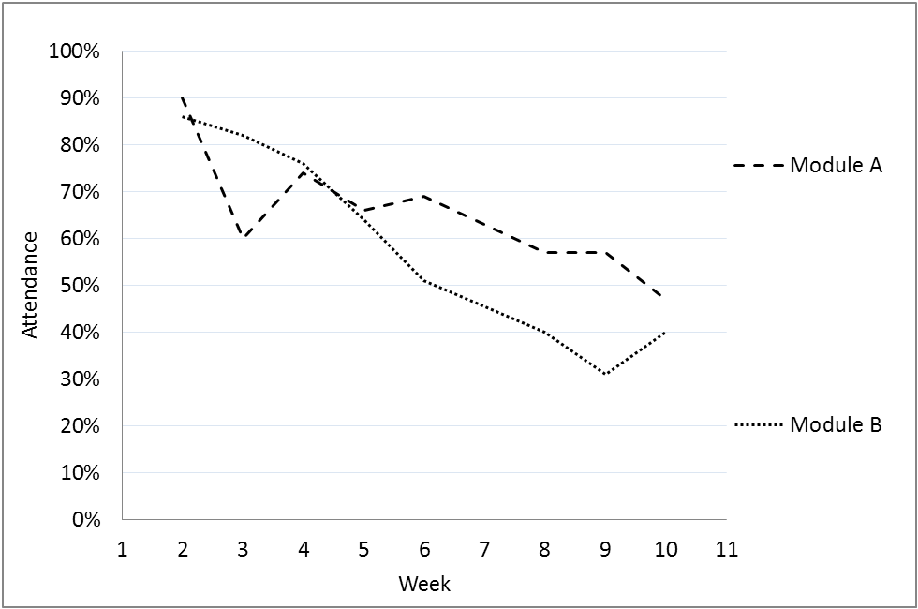

Figure 1: Problem class attendance on two traditionally taught engineering mathematics modules, Semester 1 2013—14

A study by Nguyen and Kulm (2005) looked at web-based practice and assessment tools for teaching mathematics to children aged 11-13. The children who worked with the computer-generated problems scored significantly higher than the children who continued working problems with pencil and paper in the classroom.

There are a wide variety of methods, software packages and specific implementations used, ranging from using an online approach to present specific topics (Mavrikis and Maciocia, 2003) to using online tests at regular intervals for all material (Golden and Stripp, 2006).

2. Comparison of Teaching Methods

2.1 Summary of differences
The difference in structure of the flipped approach as compared with the traditional course format is summarised in Table 1. Both formats are for year-long, 20-credit modules for first year engineers from varying departments studying the same syllabus. Note that timetabled sessions are 50-minutes in duration, and these are the units used for counting lectures and problem classes.

The main differences in approach are that two or three short (10-15 minute) video lectures replace each face-to-face lecture, quick online tests follow each video, and problem classes are doubled in frequency and given more structure.

 | Traditional | Flipped
Lecture format: | Large-group, face-to-face | Video-lectures, at home
Number of lectures: | 2 per week | 3 short videos, twice a week
Number of problem classes: | 1 per week | 2 per week
Problem class format: | Exercises, reactive tutoring | Structured classes, proactive teaching
Continuous assessment: | Semester 1 take-home test | Online tests following videos
Additional resources: | Typed notes, webpage/VLE, office hour | Typed notes, exercise booklet, online discussion board, webpage, office hour

Table 1: Comparison of teaching formats

2.2 Video delivery
The videos are best described as for-purpose ‘chalk-and-talk’ short films, made using minimal equipment (camcorder, lapel-mic, umbrella lights and blackboard in a standard office). Cutaways to narrated slides also feature in a few places. The videos are hosted, unlisted, on Youtube and students access them as embedded into a page within the Assessment in Mathematics (AiM) learning-environment, itself mostly developed at our department. AiM allows for each video to be followed by mathematical questions, randomly varied by student, and the underlying software is able to manipulate algebra so as to accept any valid rearrangement of a correct answer. It also gives instant feedback on student responses and records all activity, allowing us to track engagement and performance.

2.3 Problem classes
In a standard week students complete two iterations of the cycle: log in to AiM > watch 3 videos > rewatch if necessary > complete the online tests > attend a problem class. Additionally, students are encouraged to work on a booklet of practice exercises independently, supported by the course notes and staff or peers on an online discussion board.

Students are assigned to a problem class group of size 40. These groups meet twice a week. The class is run by a tutor who recaps and reinforces the theory seen in the videos (5-10 minutes), encourages input on an example demonstrated at the board (5-10 minutes), then sets problems for students to work on, encouraging peer-discussion. Each problem class has a lesson plan which is made available subsequently to students via the course webpage.

The format for the new problem classes differs from our previous approach. The ratio of teachers to students was theoretically better in the traditionally-taught regime, with 20-30 students per teacher or assistant, but the class was reactive, with students working on exercises and teaching staff responding to demand for assistance. This often resulted in many students lacking direction or falling weeks behind on the practice problems.

3. Methodology

A pilot implementation of our scheme was introduced in 2013-14, restricted to a module for one of the engineering departments (Module C, n=236), with modules for two further departments directly comparable (Module A, n=137, and Module B, n=161). The latter two modules were lectured in a single group. All students had attendance recorded at problem classes and received feedback questionnaires at the end of each semester. Data on the use of the video-system (AiM) was recorded for students on Module C. The exam was identical for all students and sat concurrently.

Raw exam data for the preceding two years was also available, where all three modules were taught in the traditional format with a common exam, allowing for an analysis of exam performance that could control for variations in the relative abilities of students on different courses.

4. Analysis

4.1 Engagement
Attendance at problem classes was considerably better across the year for the new format, (see Figures 2 and 3, and Table 2). Students attended approximately three times as many problem classes across the year, due to a higher attendance rate (77% compared to 50-60%) over twice as many scheduled classes.

 | Average attendance rate | Average no. classes attended
Module A | 59% | 10-12*
Module B | 50% | 7.5-11.5*
Module C | 77% | 31.5

Table 2: Summary of attendance data. (An asterisk indicates incomplete data towards the end of the course leading to the shown uncertainty.)

Additionally, as students were unable to access the online tests until they had watched the relevant video in full without fast-forwarding, we were able to determine the number of students who had watched each video on time (see Figure 4). The data indicates that the vast majority of students (86%) watched at least 80% of the videos on time, and half of students watched at least 97% of the videos on time. It is possible, and indeed likely, that students who had not watched the videos on time watched them at a later date, but we did not have a method for tracking such engagement.

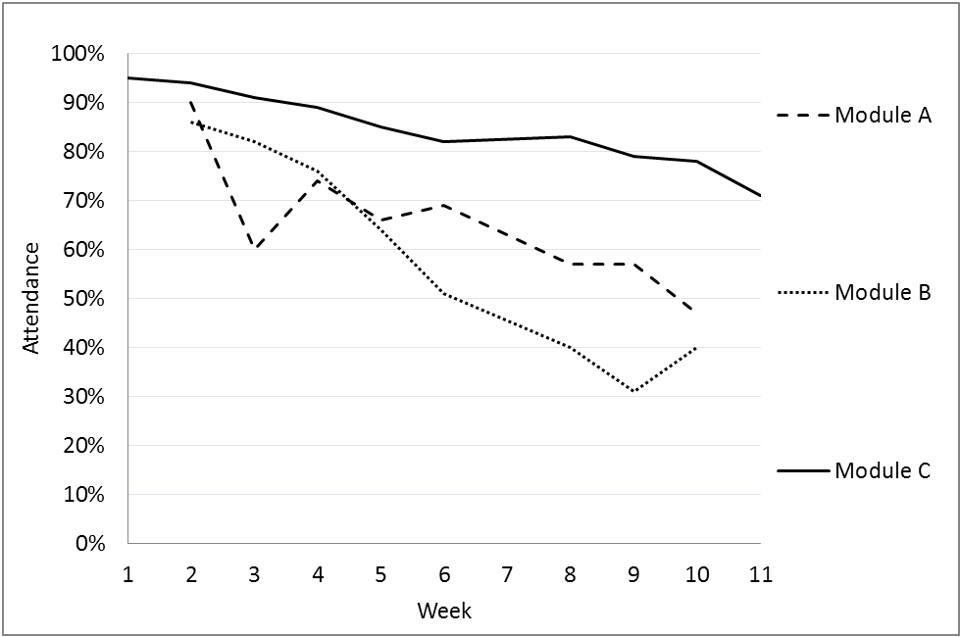

Figure 2: Problem class attendance, Semester 1. Module C was taught in a flipped format, whereas Modules A and B were taught traditionally.

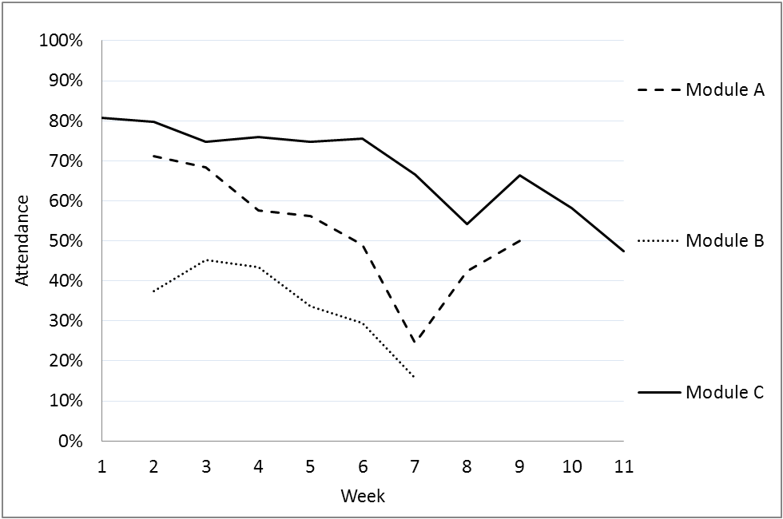

Figure 3: Problem class attendance, Semester 2. Module C was taught in a flipped format, whereas Modules A and B were taught traditionally.
(Easter break occurred after Week 8)

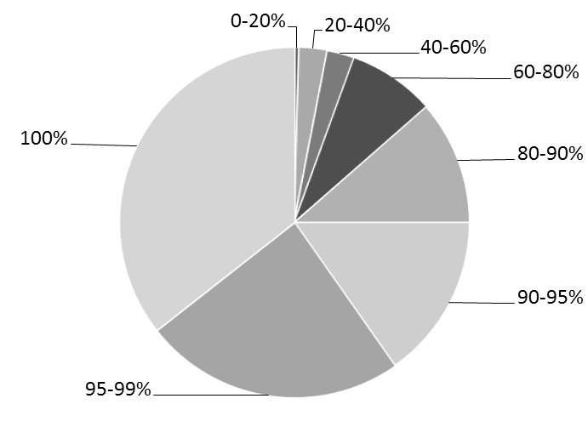
  Proportion of Tests completed | Frequency
  0-20% | 1
  20-40% | 6
  40-60% | 6
  60-80% | 19
  80-90% | 27
  90-95% | 36
  95-99% | 57
  100% | 84
  Total: | 236
Figure 4: Proportion of videos watched on time
(Students who withdrew mid-course not included)

  - Student satisfaction
Module feedback from students was very positive. In Semester 1, over 94.9% were satisfied or very satisfied with the flipped course in the end-of-semester questionnaire (118 responses), and the figure was 88.7% in Semester 2 (81 responses). Additionally, across the two semesters, 115 of 168 comments mentioned online videos when asked what was good about the module, and only 5 comments suggested traditional lectures would improve the module.

Satisfaction rates were also high for the traditionally taught courses. In Semester 1, the figures were 97.6% and 94.3% satisfied or very satisfied for the traditionally taught courses (42 and 72 responses respectively), and in Semester 2, 100% and 98.5% (24 and 66 responses). This indicates that the lower attendance rates on the traditionally taught modules were not due to low levels of student satisfaction.

Below, we cherry-pick some of the best comments from students. Full questionnaires are available from the authors on request. From the student feedback questionnaires, “What was good about the module?”:

- EVERYTHING. I love this style of teaching. Problem classes are a fun, relaxed atmosphere. Perfect level of difficulty.
- Loved the online video lecture system. It gave me the chance to work through the material at my own pace, pausing the lecture to take down clear and detailed notes. The problem classes reinforced what I had learnt at home and allowed me to ask any questions that arose when I was watching the videos.
- I feel this module is very well done, especially with the usage of online lectures and problem classes, which deeply help my understanding of the taught material.
- The combination of video lectures and problem classes is very effective. It allows students to learn when they are most motivated and it enables students to pause and replay the lectures.
- Maths videos & tests were in my opinion the way forward. By recording the lectures, the lecturers make minimal mistakes. They also make the time spent at the university more effective for students as they receive individual help on problems & are able to question things freely.
- The online video lectures are very useful as they can be paused, giving you time to take notes. The explanations given by the lecturers in the video are usually of a very high standard. The level of content is high, yet I do not feel unable to cope.
- I like the online quiz and test concept since it gives a sense of freedom in learning.

4.3 Exam performance
To understand the impact of the new teaching method on exam performance, we looked at three years’ worth of exam data (2011-12, 2012-13 and 2013-14) to allow us to control for variations in the difficulty of the exams and relative abilities of the student intakes. Elaborating on the last point, students taught on Module A tend to be weaker mathematically than those on Modules B and C, but our experience is that students on the latter two are broadly comparable. To allow us to control for this properly, we applied a linear model to the data which took as inputs the year, the module code, the raw exam mark and the teaching method for each student.

The linear model returned the conclusion that our approach adds 8 marks (with a 95% confidence interval of 4 to 12 marks) to the expected grade of a student. Figure 5 shows cumulative plots of the exam data for Modules A, B and C in 2012-13, when all courses were taught in the traditional format, and 2013-14, when Module C was changed to the flipped approach. A notable feature is the gap which has opened up between Module C and the other two modules.

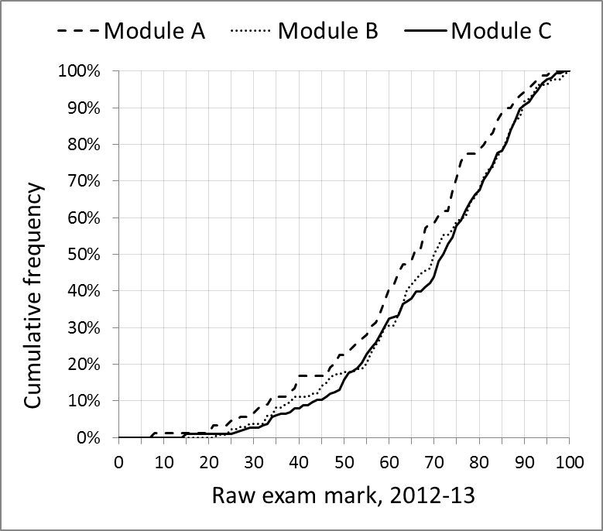 | 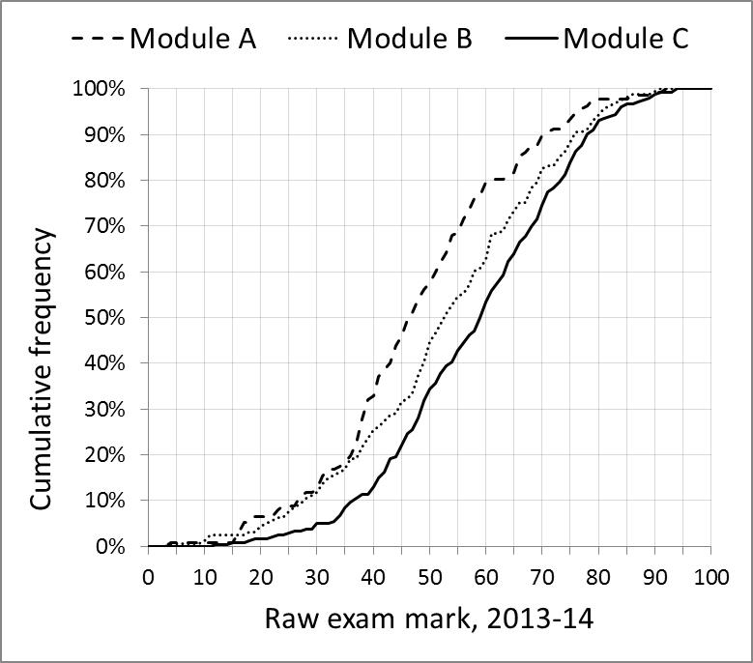

Figure 5: Cumulative plots of raw exam marks.

A summary of the raw exam data for the three years is shown in Table 3. The important aspect is in the relative standing of the average grades. Notice that in 2013-14 there was a 10-point gap between the highest scoring cohort (Module C) and the lowest (Module A).

 | Module A | Module B | Module C
2011-12: | 48.1 | 54.7 | 47.5
2012-13: | 63.6 | 68.5 | 69.3
2013-14: | 48.1 | 53.1 | 58.4

Table 3: Comparison of average raw grades on Modules A, B and C.
In 2013-14, Module C was taught in a flipped format.

5. Conclusions

We believe the data indicates that a flipped approach to teaching mathematics can significantly improve student engagement and attainment while maintaining high levels of students satisfaction. Indeed, there is some evidence from some student comments that this approach could be considered an enhancement of the student experience. The techniques we have used are low-cost and low-maintenance, and could easily be applied by other higher education institutions to large cohorts in STEM subjects and beyond.

The flipped approach outlined in this paper was extended to around six hundred first-year engineering students in 2014-15, and in 2015-16 we are teaching around a thousand students in this way. Formal analysis of the data is required to make firm claims, but it seems the approach continues to succeed in terms of engagement and student satisfaction. Finally, analysis of further raw exam data should allow us to make firmer claims as to the effects on performance of this method.

6. References

D. Marcy and M. Brint, 2012. Transforming an undergraduate introductory biology course through cinematic lectures and inverted classes: a preliminary assessment of the clic model of the flipped classroom, NABT Biology Education Research Symposium, available at http://www.nabt.org/websites/institution/index.php?p=720

B. Lin and C. Hsieh, 2001. Web-based teaching and learner control: A research
review. Computers and Education, 37(3-4), 377-386.

M. Mavrikis and A. Maciocia, 2003. Incorporating assessment into an interactive
learning environment for mathematics, Maths CAA Series: June 2003, available at http://icse.xyz/mathstore/repository/mathscaa_jun2003.pdf.

D. Nguyen and G. Kulm, 2005. Using Web-based Practice to Enhance Mathematics Learning and Achievement, Journal of Interactive Online Learning, 3 (3).

K. Golden and C. Stripp, 2006. Blending on-line and traditional classroom-based teaching, The mathematical education of engineers V, Loughborough University, 11-12 April 2006, available at http://www.mei.org.uk/files/pdf/LOUGHBOROUGH_PAPER_D3CS.pdf

This comprised the full amount of directly comparable data we had for these modules. Prior to 2011-12, there were significant differences in the way the modules were structured.
Anecdotally, we think that the correct conclusion is likely to be towards the bottom-end of the confidence interval, as the marks for 2011-12 are slightly out of line with our usual findings on relative abilities. We should be able to feed in data from subsequent years to enable us to draw firmer conclusions in the future.

